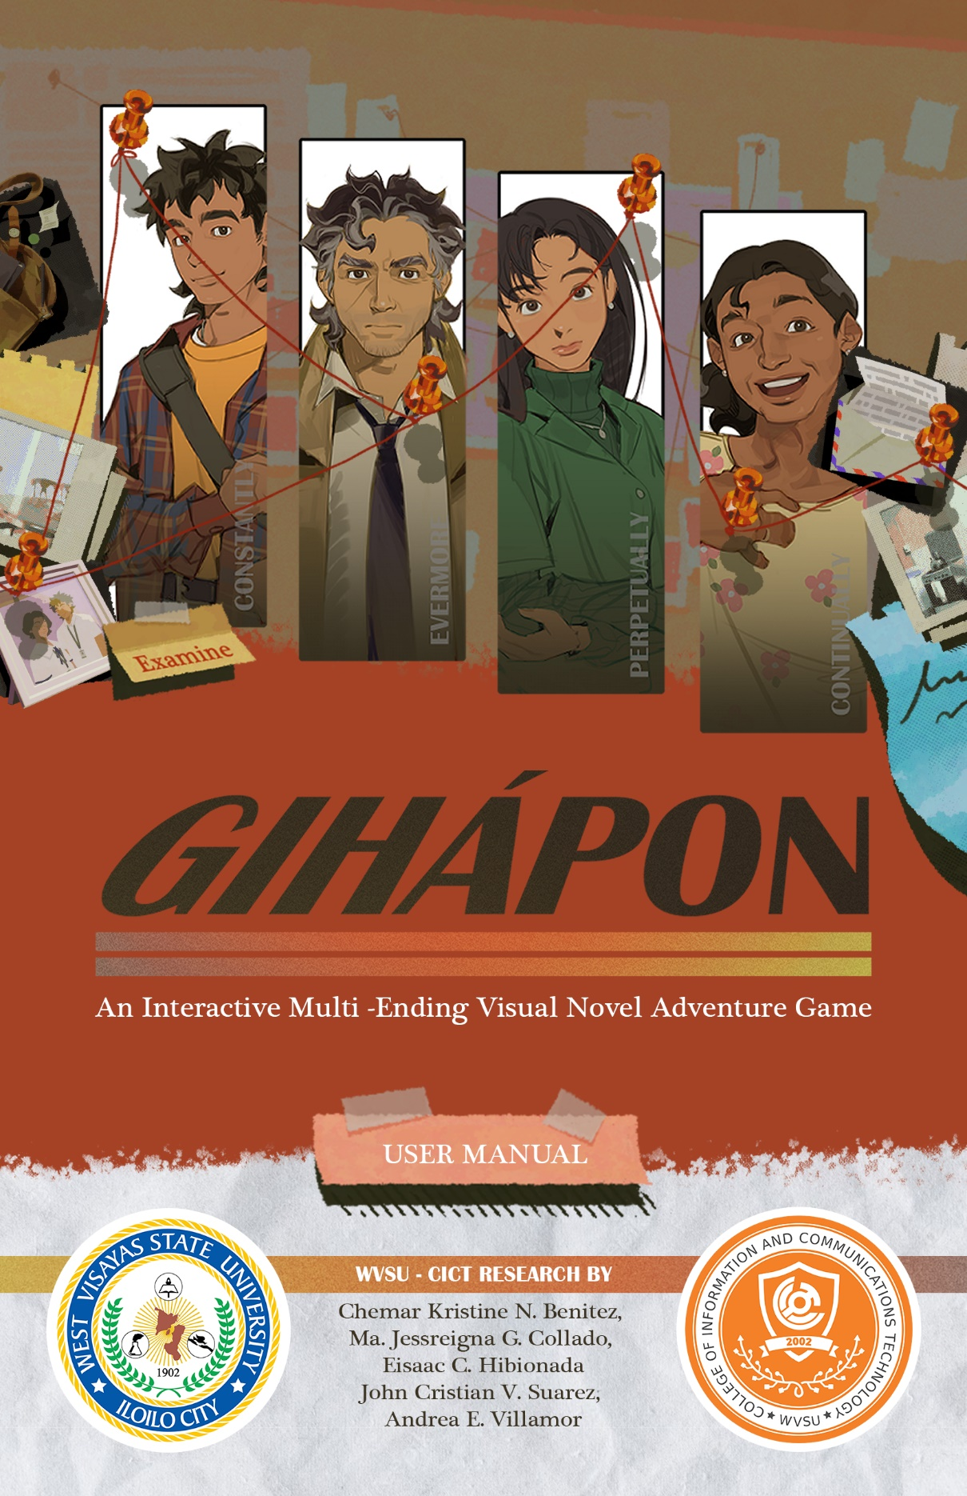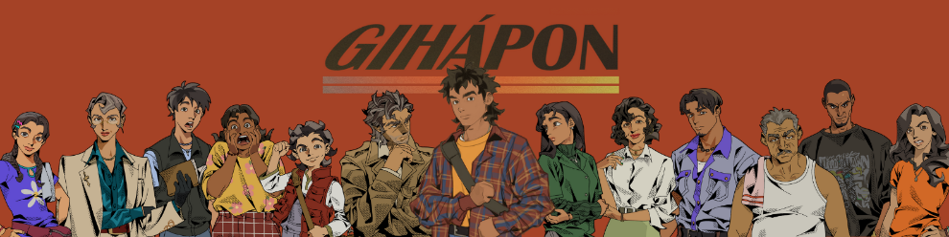

**GIHÁPON**

AN INTERACTIVE MULTI-ENDING

VISUAL NOVEL ADVENTURE GAME

**USER MANUAL**

**WVSU – CICT RESEARCH**

by

Chemar Kristine N. Benitez

Ma. Jessreigna G. Collado

Eisaac C. Hibionada

John Cristian V. Suarez

Andrea E. Villamor



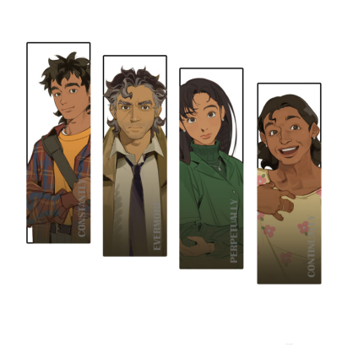

**GIHÁPON**

AN INTERACTIVE MULTI-ENDING

VISUAL NOVEL ADVENTURE GAME

An Undergraduate Thesis

Presented to the Faculty of the

College of Information and Communications Technology

West Visayas State University

La Paz, Iloilo City

In Partia l Fulfillment

of the Requirements for the Degree

Bachelor of Science in Entertainment and Multimedia Computing

by

Chemar Kristine N. Benitez

Ma. Jessreigna G. Collado

Eisaac C. Hibionada

John Cristian V. Suarez

Andrea E. Villamor

March 2023



**DISCLAIMER**

This project, called "Gihápon: An Interactive Multi-Ending Visual Novel Adventure Game," and its corresponding documentation have been submitted to the College of Information and Communications Technology at West Visayas State University as part of the requirements for a Bachelor of Science in Entertainment and Multimedia Computing.

The project is the result of the researchers' work, with the exception of any explicitly credited sources. The researchers give the College of Information and Communications Technology permission to use, reproduce, publish in local and international journals/conferences, or distribute copies of this project and its documentation, in whole or in part, as long as the researchers are acknowledged.

**TABLE OF CONTENTS**



**Disclaimer** i

**Table of Contents** ii

**Getting Started** 1

Introduction

System Requirements 2

Installation 3

**Usage** 5

**Troubleshooting** 10

**FAQs** (Frequently Asked Questions) 12

**Meet the Team** 14

**GETTING STARTED!**

**INTRODUCTION**



**GIHÁPON** is an interactive visual novel game that utilizes a narrative-driven storyline through character interaction and incorporates elements of the adventure game genre, such as multiple branching paths and endings. The setting for the game is a fictional Filipino town, with characters exhibiting various everyday Filipino traits. The integration of these two genres significantly enhances the interactivity aspect of the narrative and increases the immersion of the players through the consequences of their choices on the progression of the story.

This **User Manual** serves as a comprehensive guide for the deployment and utilization of Gihápon's core functionalities and gameplay. It provides detailed information regarding the system requirements, installation process, usage instructions, troubleshooting procedures, frequently asked questions, and contact information for the development team, enabling users to fully leverage the capabilities of this visual novel game.

**SYSTEM REQUIREMENT**



**GIHÁPON’s Minimum System Requirements.**

|  |  |
| --- | --- |
| OS | Windows 7 |
| PROCESSOR | 1.8GHz Dual-Core CPU |
| MEMORY | 4 GB RAM |
| GRAPHICS | Integrated Graphics |
| STORAGE | 350 MB Availbale Space |

It is required that a user's computer have OpenGL 2, DirectX 9, OpenGL ES 2, or WebGL to run GIHAPON. The model-based renderer requires OpenGL ES 3 or WebGL 2.

**INSTALLATION**

How to run the GIHÁPON Visual Novel Game:

1. **Download “GIHÁPON-1.0-win.zip”.**

Use the QR Code below to access Gihápon.



1. **Right click on it, select “Extract all…”**

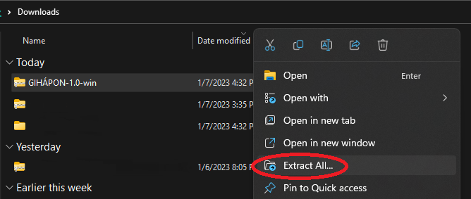

1. **Save the file in any location by clicking “Browse…”, then “Extract”.**

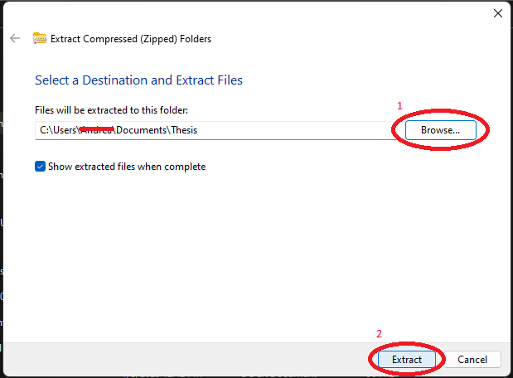

1. **Go to your extracted file, open the folder, and click the “GIHÁPON” with an application type.**

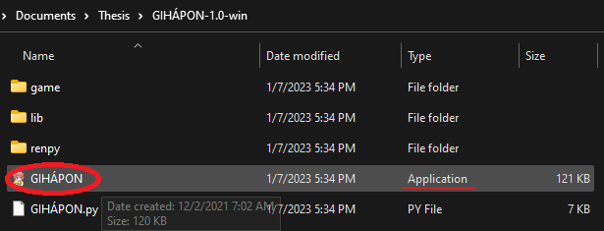

1. **Open the application and start the game!**

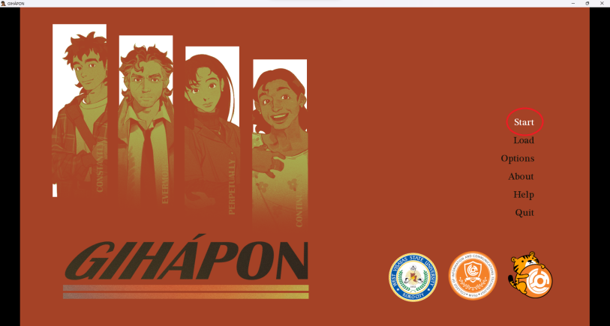

**USAGE**

1. **Open the Application.**

Upon launching the application, you will be directed to the Main Menu Screen. To initiate a new game, simply click on the "Start" button. Alternatively, to resume a previously saved game, click on the "Load" button and select the saved game file.

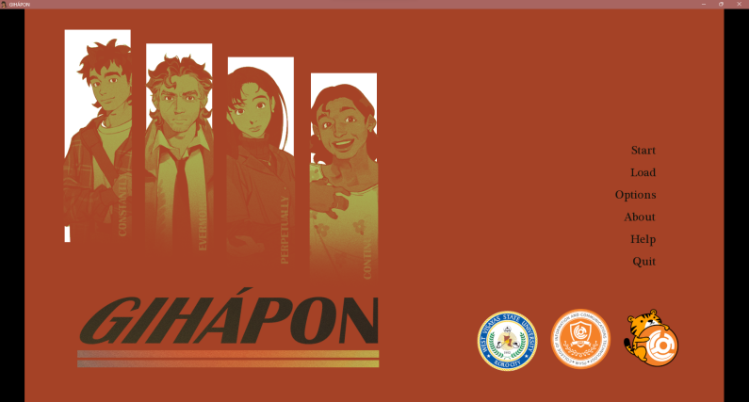

1. **Select to start the Game!**

You have the option to commence the Gihápon experience anew or resume the ongoing investigation.

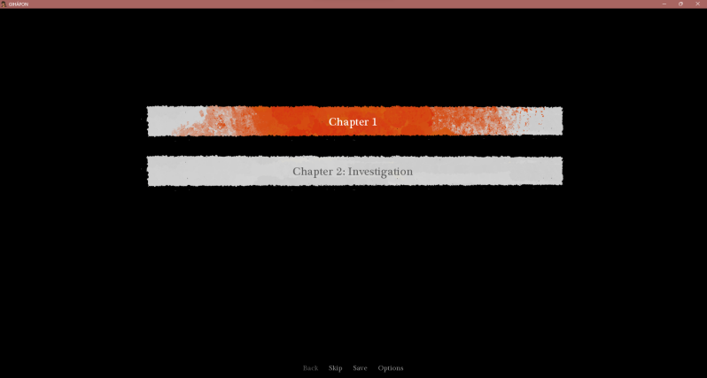

1. **Basics of the Visual Novel Game.**

The unfolding of the narrative through Max's first-person perspective can be observed and decisions can be made on his behalf throughout the story by utilizing either the mouse or the space bar.

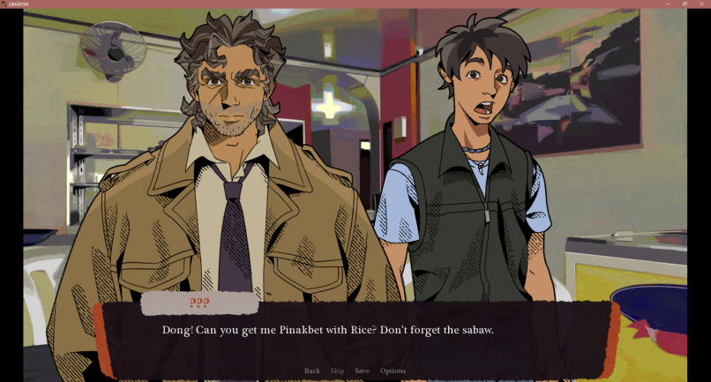

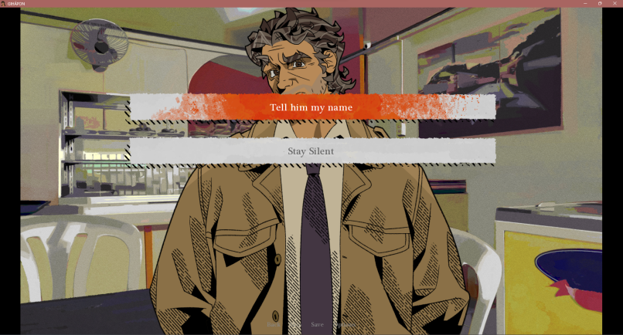

1. **Investigation Section.**

This section will feature an investigative gameplay where players will encounter puzzle-solving tasks, including code riddles and item-based puzzles.

1. Max needs to investigate the room but it’s locked.

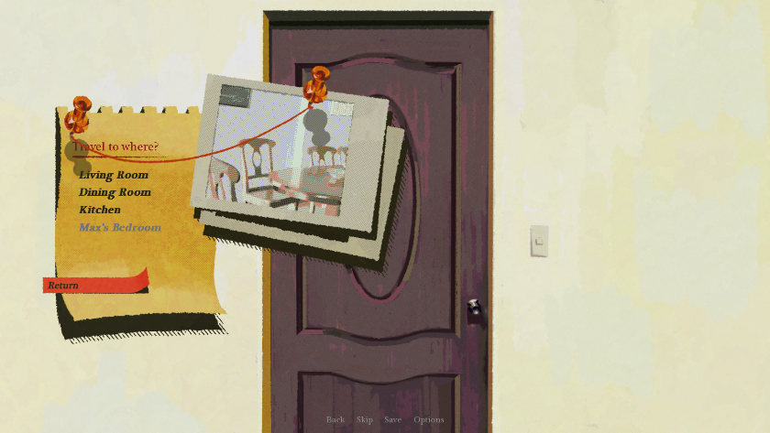

1. The key is in a safe box, the player needs to figure out the code.

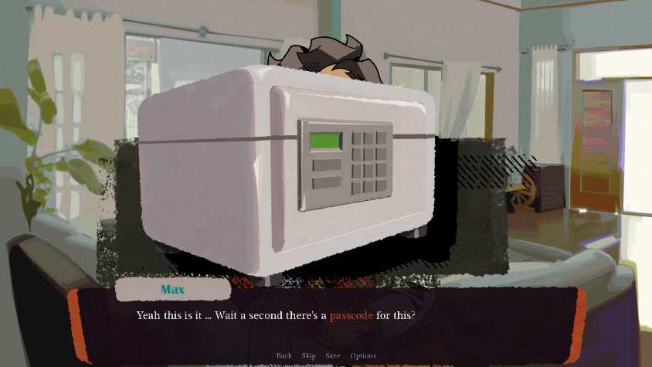

1. The player must find clues at different locations. A notebook at the kitchen is found.

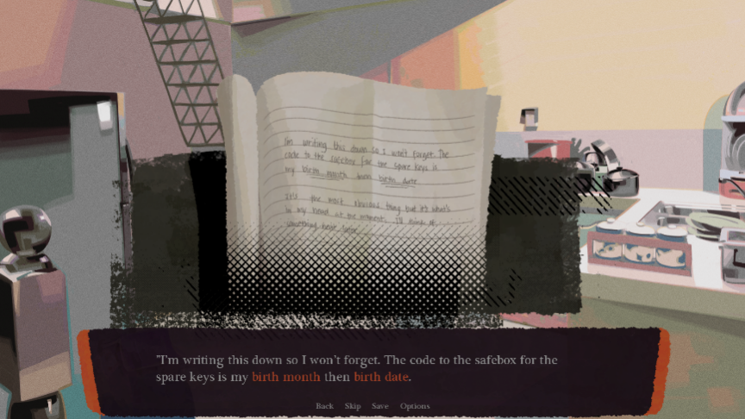

1. Check the Dining Room for some clues. Notice the encircled date on the calendar.

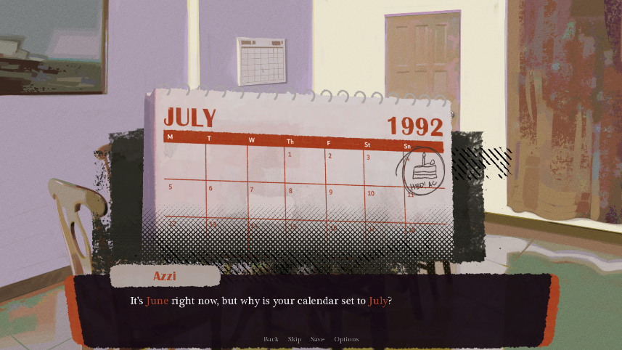

1. The player enters the code and opens the safe box.

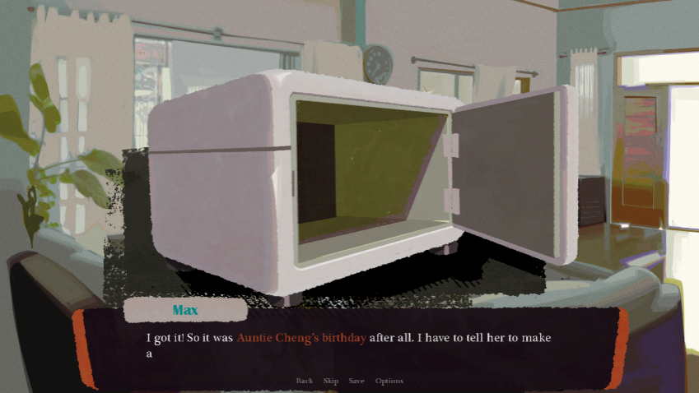

1. The player enters the code and opens the safe box.

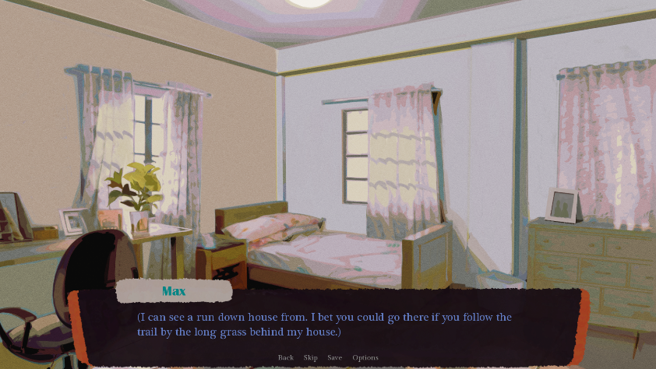

1. **What’s your Ending?**

The game offers three distinctive endings - a positive, a neutral, and a negative outcome - which are influenced by the player's judgments and decisions.

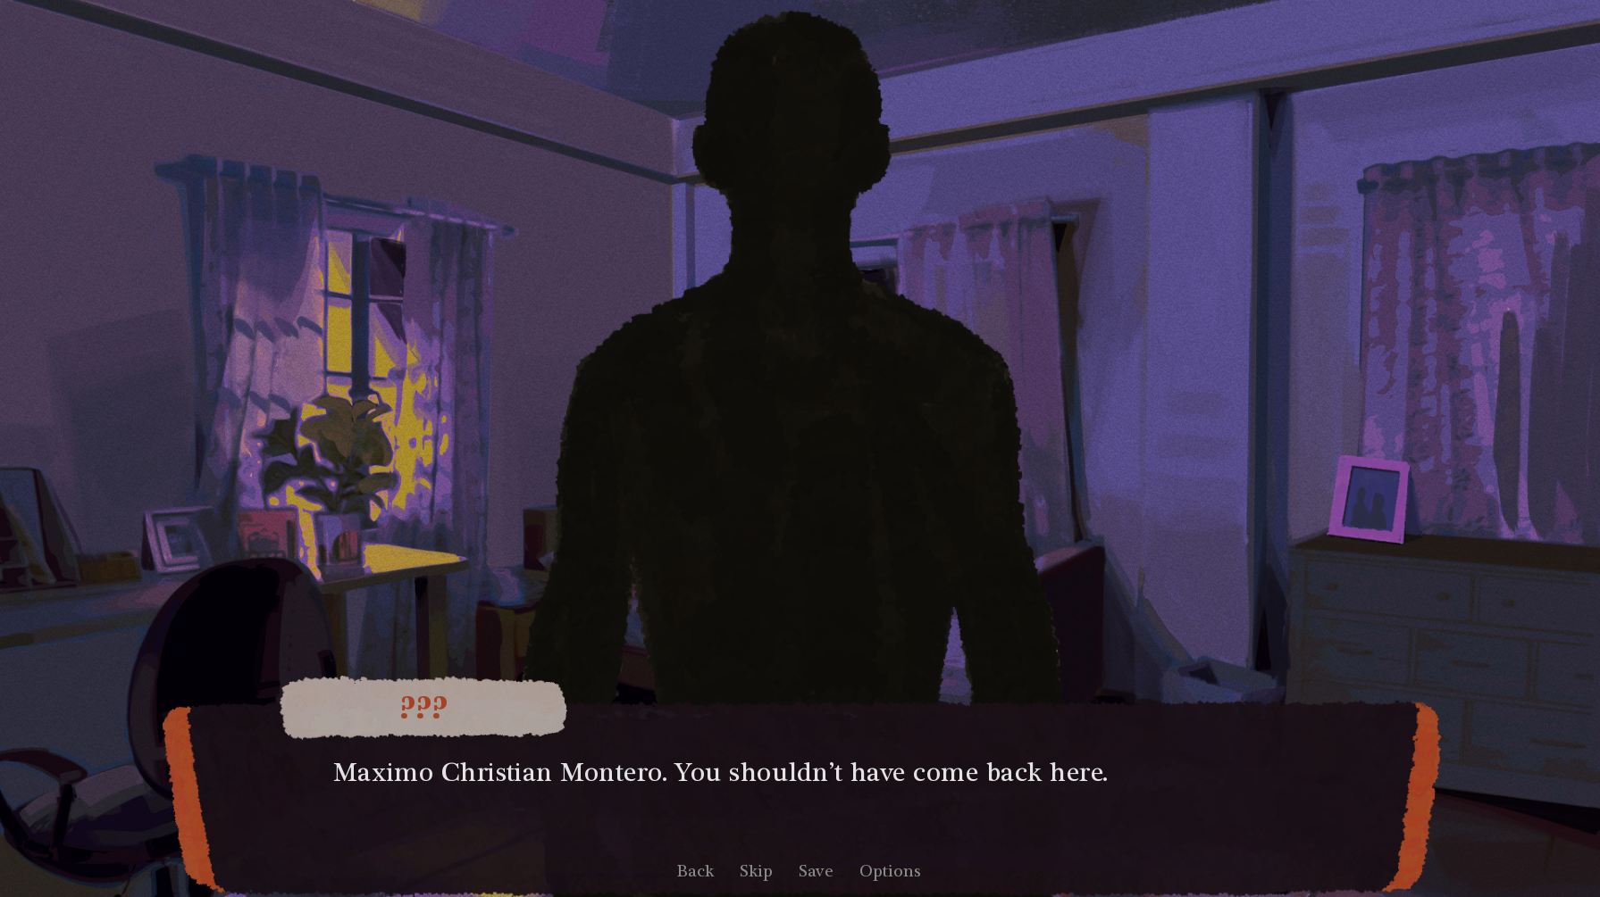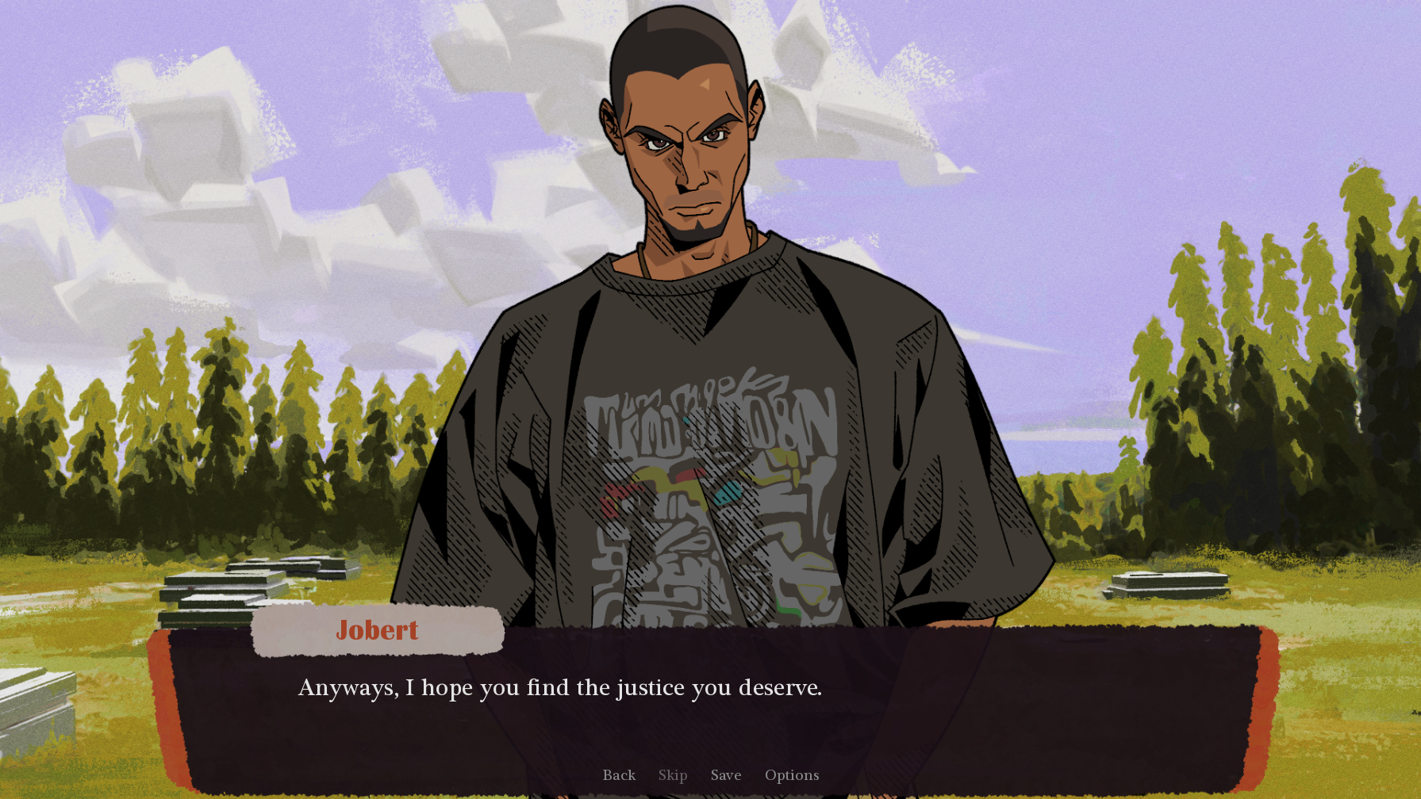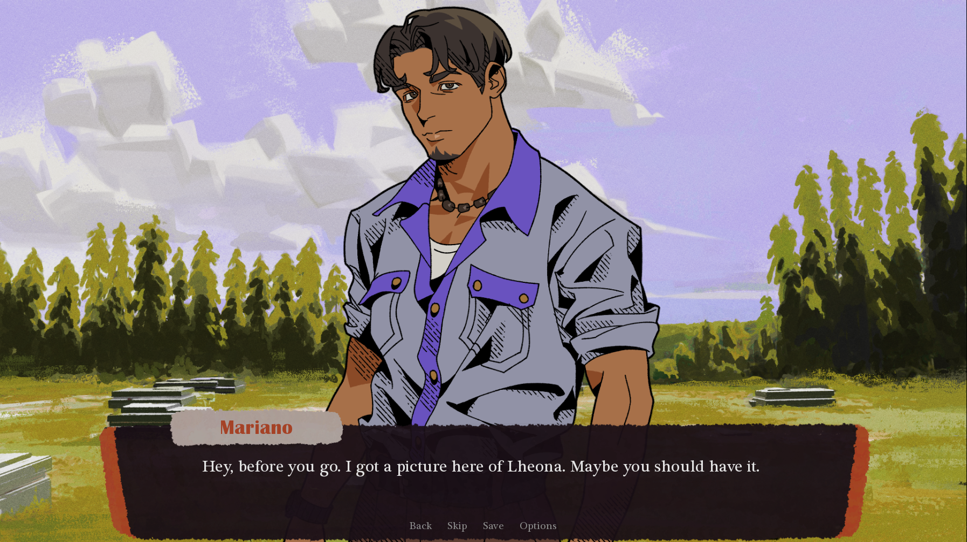

**TROUBLESHOOTING**



**Dealing With Display Problems**

When running hardware accelerated Ren'Py games, a small percentage of systems could encounter issues. Checking for an update to your graphics card drivers should be your first step in fixing these issues, which are frequently brought on by problematic graphics drivers.

If upgrading your video drivers does not fix the problem, you should consider switching video renderers, using the following steps.

1. Hold down Shift while starting Ren'Py, or press Shift+G once Ren'Py has started.
2. From the "Graphics Acceleration" menu that appears, choose the renderer to use.
3. Choose "Quit", then restart Ren'Py.

We suggest trying the GL and ANGLE renderers. The GLES renderers may not function on desktop hardware.

**On Suspend/Resume**

There are systems that lose textures when a computer is suspended and resumed. This is likely a problem with the computer or its device drivers, but it is possible to force Ren'Py to reload the textures by resizing the window or pressing the F key to toggle full screen mode.

**Windows Encoding Problems**

Ren'Py will fail to start on Windows if it's placed in a directory with a full path that isn't representable in the current system language. For example, if Ren'Py is in the directory:

C:\ビジュアルノベル\renpy-6.16.0-sdk\

and the system is set to use the English language, Ren'Py will be unable to start. To fix this problem, start the control panel, select "Region and Language Options", "Advanced", and change the Language for non-Unicode programs.

*\** *In case no solutions are found, it is recommended to contact our team. You can get in touch with one of our members by using the email addresses that are available on page 14. \**

**FAQs** (Frequently Asked Questions)



**Q. What is "Gihápon" and what is it about?**

* Gihápon" is an interactive visual novel adventure game set in a fictional Filipino town. The story revolves around Max who returns to his hometown to uncover the truth behind his friend's disappearance after receiving a letter from an unknown witness. Players can experience a narrative that is driven by character interaction and adventure game genre elements, such as multiple branching paths and endings. The game features characters who portray various everyday Filipino traits.

**Q. Where can I play "Gihápon"? On mobile or PC?**

* Unfortunately, "Gihápon" is only available on PC.

**Q. How do I play "Gihápon"?**

* To play "Gihápon," you will read through the story and make choices that affect the direction of the narrative. These choices can lead to different outcomes, multiple branching paths, and endings. The game also features adventure game elements such as puzzles, exploration, and item management.

**Q. How long does it take to complete "Gihápon"?**

* The length of "Gihápon" can vary depending on the choices you make and the paths you take. However, the game typically takes around 2-3 hours to complete.

**Q. Can I replay "Gihápon" to see different outcomes and paths?**

* Yes, "Gihápon" features multiple branching paths and endings, so replaying the game can lead to new experiences and outcomes.

*\*If you have any further inquiries, please reach out to our team. \**

**Meet the Team!**



**Eisaac Hibionada**

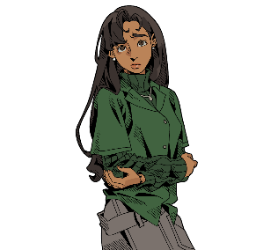[eisaac.hibionada@wvsu.edu.ph](mailto:eisaac.hibionada@wvsu.edu.ph)

**Andrea Villamor**

andrea.villamor@wvsu.edu.ph

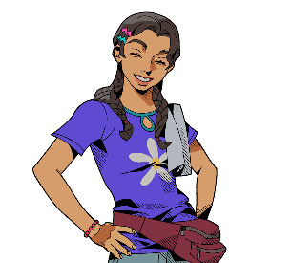

**Ma. Jessreigna Collado**

[reigncollado@wvsu.edu.ph](mailto:reigncollado@wvsu.edu.ph)



**John Cristian Suarez**

[johncristian.suarez@wvsu.edu.ph](mailto:Johncristian.suarez@wvsu.edu.ph)



**Chemar Kristine Benitez**

[chemarkristine.benitez@wvsu.edu.ph](mailto:chemarkristine.benitez@wvsu.edu.ph)



**GIHÁPON**

AN INTERACTIVE MULTI-ENDING

VISUAL NOVEL ADVENTURE GAME



A Research Paper Authored by

Benitez, Collado, Hibionada, Suarez, Villamor

Bachelor of Science in Entertainment and Multimedia Computing 4A